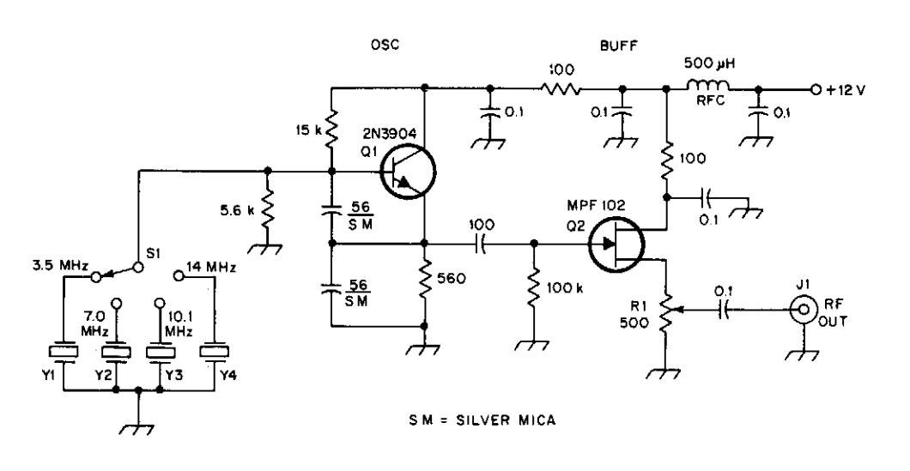
Signal Generator
Put variable capacitor in series (parallel?) with the crystals to vary them?

