BC-221 Notes:
The two phone plugs: There must be a “dummy” plug in one or the other. Removing it cuts the Filament supply, to prolong battery life. The “Off” position on the Xtal switch cuts only the B+.
The audio circuit is for High-impedance headphones; 8 ohm phones will work but the volume will be low.
Frequency Meter BC-221-(*) is calibrated in two ranges: 125 to 250 kc and 2,000 to 4,000 kc. By the use of the 2nd, 4th, and 8th harmonics of the low-frequency range, any frequency between 250 and 2,000 kc can be obtained; by the use of the 2nd, 4th, and 5th harmonics of the high-frequency range, any frequency between 4,000 and 20,000 kc can be obtained...
==========================================================================================
Here are another person’s extensive notes and explanations. My apologies to the original author; I do not know the original source of this excellent document.
Checking the chassis there was no signal from the crystal oscillator. Having nothing to lose I took the crystal case apart (must be different from the tube type) and was surprised what was inside. One side contained a temperature switch. I heated up the sensor and it still worked, popping loud as it opened the switch; I've seen this used on other equipment as a way to prevent overheating but it's strange that it would be used inside the crystal container. The other parts were even more unusual and amazing (see pics below). I soldered a more modern 1 MHz crystal in its place to the socket terminals and the circuit worked. After this I decided to clean up the original crystal and put it back in the unit but it still didn't work. Tracing the wires inside the crystal case to the octal base showed why - the crystal wasn't even connected to the circuit. There were obvious signs of tampering on the socket; pieces of cut wire and solder on some terminals. The schematic did not show any thermal switch but it may have been hidden as part of the "crystal". It could be that the thermal switch had become intermittent and someone tried to bypass the wiring and failed. I corrected the wiring and the old crystal was now working!
I cleaned and lubricating all the controls, especially the trimmers (they were extremely hard to turn until lubricated); then I did a quick alignment and was amazed how accurate this unit was; "good enough for government work" as they say (the crystal trimmer is located behind the nomenclature plate on the front panel). Looking at the frequency chart the precision is as follows:
Freq Range Accuracy Band
125 - 250 KHz 100 Hz Low
250 - 500 KHz 200 Hz Low
500 - 1000 KHz 400 Hz Low
1000 - 2000 KHz 800 Hz Low
2000 - 4000 KHz 1000 Hz High
4000 - 8000 KHz 2000 Hz High
8000 - 16000 KHz 4000 Hz High
16000 - 20000 KHz 5000 Hz High
Any frequency between 125 Khz and 20 MHz can be obtained with this unit.
The quick calibration works by tuning the "Crystal Check Points". There is a Xtal check point on each page allowing for much improved accuracy even for a unit this old. Turn the switch to Xtal Check, dial in the numbers for the Crystal Check Frequency on the page needed for your frequency; then zero-beat the tone for lowest tone using the "Corrector" dial (you should be able to make the tone almost disappear for the best reading).
Now you’re ready to align your equipment. It's very time consuming but it works and it works very well. The only caveat is to know which harmonic you're on and double check it. The "HET OSC." mode is used to check transmitters allowing the unit to become an accurate receiver using heterodyne to tune the transmitter oscillators. With a long wire connected to the terminal you can receive some shortwave stations but only the strongest harmonic will come through. WWV for instance is on every harmonic when tuned to 5000 KHz so you might hear 3 different stations at once!! You will also still hear the HET oscillator but it can be nulled to be able to hear voice. The "XTAL ONLY" is used to calibrate receivers providing an accurate transmitted CW signal which can be used to tune the oscillators of the receiver.
You can use 2 sets of headphones. A plug must be inserted (in either jack) to apply power even if the power switch is on. A contact switch is built into the phono plug. This was to conserve battery life for the 6 V battery; the high voltage stays hot with the power on and phono plug disconnected. I used alligator clip test leads to connect the three power connectors when out of the chassis and an empty 1/4" phono connector to keep the power on.
The newer headphone (8 ohm type) will work but the volume will be very low. The high impedance type (~1000 ohm) will provide maximum volume. If you have good hearing then the 8 ohm type might be better since the clicks and beat-frequencies will not hurt your ears. Most of the 1st harmonic crystal check frequencies are very loud!
======================================================================================

What is a BC-221, and how to use it with a BA
A lot of the information I am going to present here is out on the web, in fact I am pretty sure all of it is. But several times recently I was asked, by people who know what a boatanchor is, how I could tell what frequency I was tuned to with a boatanchor. People, often used to digital readouts, look at the dials on many BAs and realize there just is not a great deal of accuracy represented there. When I say I use a BC-221 or an LM-18 some of them do not seem to understand. So, I decided one more web page needed to be created...as if there were not already enough...lol.

What is a BC-221 or an LM-XX?
The BC-221 and the Navy LM series are heterodyne frequency meters. The basic units were developed in about 1941, and the contract for first production was let in 1942.
Many different models and variations of each exist, but the basic function and performance of all of them are the same. The BC-221 is around in both wood and metal cases, while I think the LM series was always a metal case. The BC-221 normally ran on batteries, while many of the LM series came with an external power supply that worked from various (model dependant) mains voltage. The LM series has a selectable 500 Hz modulation capability that can make pre-tuning an MCW or AM radio a little easier.
They consist of two high precision variable frequency oscillators, one covering from 125 to 250 kHz and one covering 2.0 to 4.0 MHz. Using these two ranges, and harmonics of each, the units are capable of providing a stable known frequency anyplace from 125 kHz to 20.0 MHz. With interpolation of the results I have used them to 60.0 MHz before.
The basics are simple, if the low frequency VFO is tuned to 125 kHz, then its 2nd harmonic is at 250 kHz, its 4th is at 500 kHz, and its 8th is at 1.000 MHz. So, the low band 125 to 250 kHz VFO gives you coverage from 125 kHz to 2.000 MHz.
Now, the high frequency VFO (2.000 to 4.000 MHz), when tuned to 2.000 MHz, yields known signals at 2.000, 4.000, and 8.000 MHz. The 16.000 MHz signal is also there, but on HF the designers decided to use (document in this case, you will see what I mean later) the 5th harmonic above 16.000 MHz, so you tune the VFO to 3.200 MHz and above to get above 16.000 MHz.
It sounds a might confusing, but it is very simple to use.

What can a BC-221 do for me?
The BC-221 can be used for 3 basic radio transmitter or receiver frequency measurement task. They all assume that you know roughly the frequency of the device you are testing/using. By this I mean, with the frequency dials on many old radios you can tell about the freq you are on, often to +/- 100 kHz or so, but you can't tell exactly where you are. A few old boatanchors had readouts/displays that could confirm your frequency to 5 kHz or better, but the majority could not. The BC-221 and friends can tell you right where you are, sometimes to within a 100 Hz. In this day of digital readouts to 1 Hz that may not seem like much, but as few as 20 years ago having 100 Hz accuracy was outstanding.
1. - The BC-221 can measure the operating frequency of a CW or AM transmitter. It was designed in a day when SSB simply was not used, so it was not designed to support that mode. With a little thought you can make it work for SSB also.
2. - The BC-221 can be used to set a CW, MCW, or AM receiver to a desired frequency. You want to catch that Voice of Africa schedule that starts at 1100 GMT on 17725, but that is still 10 minutes away? Use the BC-221 to set your boatanchor to the right frequency and be ready for it. You don't have to wait until the transmission starts and tune around hunting for it.
3. - The BC-221 can tell you what frequency you are currently tuned to. You have tuned around 10.3 on the dial and picked up a transmission in a language you don't recognize. Using the BC-221 you can find out that the frequency is 10.330 MHz on the money, and that fact can help you determine that this is most probably All India Radio. Without the actual frequency it is much harder to tentatively ID a station if you can not hear or understand the station ID.
These last 2 receiver usages are the ones I am addressing right now with this page, later I may hit the transmitter measurement. To understand why this ability is so important, it might help if I show some example of boatanchor dials.

Boatanchor dials, why we need the BC-221.
As I mentioned before, sometimes boatanchor dials don't give you the most tuning detail. The following link will point to images of some common BA dials.
Boatanchor tuning dials and scales.
You can see from the tuning dial page that you should be able to tell within 500 kHz of where your BA is tuned, often much closer than that, say +/-20 or 50 kHz. You must have at least a rough idea of your frequency for the BC-221 or LM series to be of much help to you, the better an idea you have the quicker the BC can get you on freq or tell you your freq.

Introduction to the BC-221.
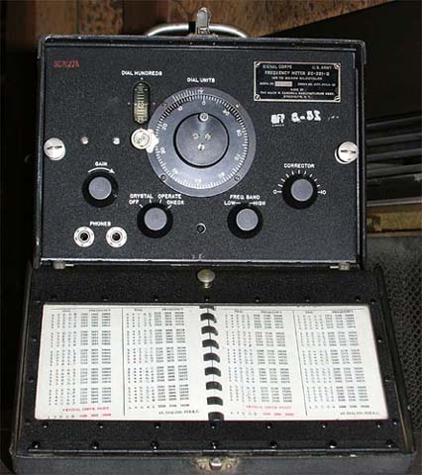
Although BC-221s come in a variety of cases, the faces and general layout are all pretty much the same. In this picture the cover is open, showing the main face and the calibration book. The calibration book is stored in the front cover and you must have the correct book for your specific BC-221.

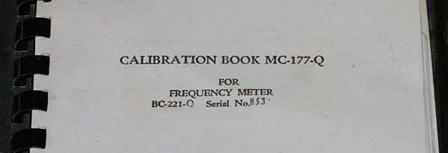
The ID plate in the upper right corner of the BC-221 has the model number and serial number of the unit. The front cover of the calibration book has the same information on it, model number and serial number. If you do not have the serial number matched book for your specific BC-221 the book is just about useless to you.
If you do not have the right book, all is not lost. With an external frequency source or meter you can make your own book, but that will be a pretty tedious process.
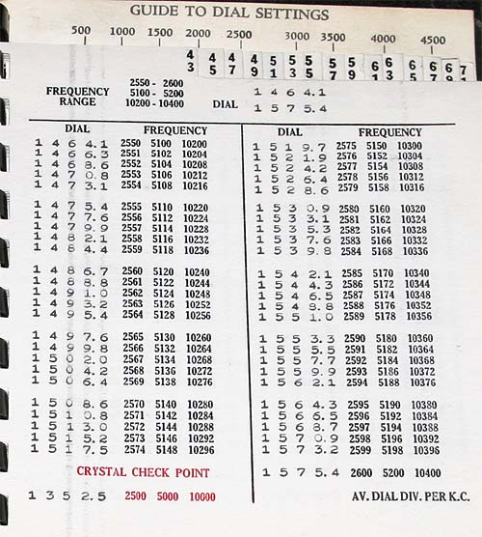
This is a typical page from the calibration book. Two columns per page. Each column has a single row of typed entries under DIAL and at least three (sometimes four) rows under FREQUENCY.
Across the top of the page you will find the basic frequency ranges and the minimum and maximum dial positions covered on that page.
At the bottom of the page will be the CRYSTAL check points to be used anytime you reference this page. Each page has a unique set of CRYSTAL check points. The frequency values of these check points are in red print, the dial values are in the same type face as the DIAL entries throughout the page.

How to read the BC dial.
The BC-221 uses a vernier dial for high accuracy. Without this the BC-221 would either be much less useful or much more complex.
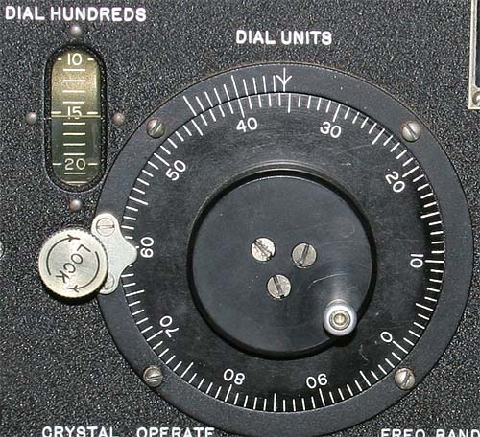
The silver "LOCK" knob must be turned counter clockwise to unlock the tuning dial. Naturally, snugging the LOCK knob down clockwise locks the tuning dial. I have run into one BC-221 that would not tune even when the LOCK was loosened, this turned out to be a mechanical failure in the locking mechanism. I have no idea if this is a common failure or not, I just throw it in here for general information.
In the above picture the BC-221 dial is set to 1535.5. Lets break down how this is determined.
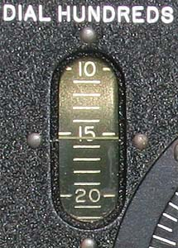

The hundreds place is read from the vertical window in the upper left corner of the BC-221 front panel. Each division in this window is 100, every 5th mark (or 500 units) is marked with a numaric value, 5, 10, 15, 20, etc, from 0 to 50. The pointer for this window in our example is between the labeled "15" mark and the next unlabeled (16) mark. Making our value more than 1500 and less than 1600, or 15XX.X. The next step is to fill in the X's.
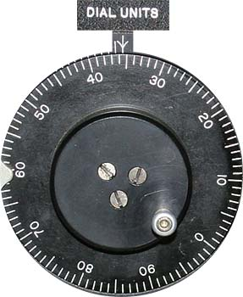

The tens and ones place are read from the main round spinning dial of the BC-221. At the center top of this dial is an unmoving pointer. Around the dial are 100 increments, with each 10, from 0 to 90, marked. In our example the pointer is indicating between the labeled 35 and unlabeled 36 mark. When combined with the 15XX.X we got in the previous step, we now have 1535.X. One more X to fill in.
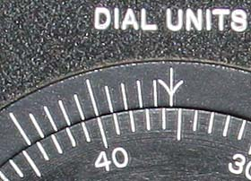

Reading the tenths position is a combination of the outer unmoving vernier scale (with its 11 unmarked hash marks, 0.0 to 1.0, note that the 0, 5, and 10 marks are taller than the others), and the hash marks (but not values) on the inner moving dial. In the picture above note that the pointer (downwards pointing arrow) is between two marks, the marked 35 and the unmarked 36. This was used in the last step to determine the 10's and 1's place. What is important is the pointer (which is the X.0 mark) is NOT lined up with a hash mark on the inner scale. On the unmoving outer scale we go to the next mark to the left (the X.1 mark), it also is not lined up with an inner mark. Neither are the next 3 outer marks. We must go to the fifth outer mark (X.5) to find an inner and an outer hash mark exactly aligned. The inner mark is the 40, but that value is not important, only that this is the first aligning set of marks. This gives us a tenths value of 5. If the third mark was lined up the tenths value would be 3, if the eighth lined up it would be 8, and so on.
Making our indication 1535.5 for all of the above combined steps. It sounds like a pain to do, but after just a little practice it is very quick and easy.
The value read from the dial will be used with the information in the log book to determine what frequency the BC-221 is indicating.

Turning on the BC-221.
To power on an unmodified BC-221 on you must plug in a pair of 600 Ohm headphones and turn the main operating switch to some position besides OFF. Without headphones plugged in the unit will not power on. This is a battery saving feature, since you can not have headphones plugged in and the case closed, the unit can not be accidentally left running (and draining the batteries) when in storage.
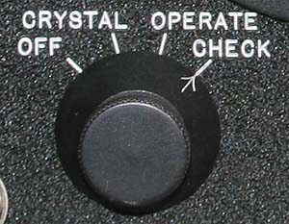
The main control knob on the BC-221 has four positions, OFF, CRYSTAL, OPERATE, and CHECK. Any position besides OFF keeps the tubes warm as long as headphones are plugged in. Like any hollow state device you must allow the BC-221 to warm up for a while before you use it, I like to have it on at least 10 minutes before first measurement, longer is better. Failure to do so will result in greater drift during the time you measure, and thus less accuracy.

Select the right band.
Before you can start with either BC-221 calibration (CRYSTAL check), or anything else you must set the BC-221 to the correct band.
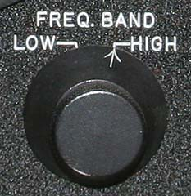
The BC-221 FREQ. BAND selector has two positions, LOW and HIGH. The LOW band provides measurement capability from 125 kHz to 2.000 MHz. The HIGH band works from 2.000 MHz up to at least 20.000 MHz.

Performing a CRYSTAL check.
Before any measurement can be taken, you must perform a CRYSTAL check and correction.
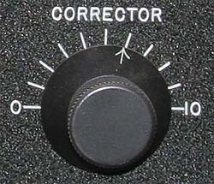

The CORRECTOR control is used to adjust the BC-221 dial to be correct in reference to a fixed crystal oscillator source. This is what provides the VFO's and their dials with the accuracy required over a broad range with simple circuitry.
To perform the CRYSTAL check you must have a rough idea of your intended frequency.
1 - Find your intended frequency in the calibration book. Note the CRYSTAL check point in red at the bottom of the page, the important number is the DIAL setting.
2 - Turn the main control knob to the CHECK position and the DIAL to the number indicated at the bottom of the page for the CRYSTAL checkpoint.
3 - Listen to the headphones and adjust the CORRECTOR control. You want to achieve zero beat in the headphones.
4 - Turn the control knob to OPERATE. You are now ready to determine or set your exact radio frequency. Each time you go to a new page in the calibration book you must perform a CRYSTAL check, I would recommend you do so after a period of time also, even if you stay on the same page. With time the BC-221 will drift a little in frequency, your CRYSTAL check is how you negate this drift.

How to determine the frequency of interest.
I have covered how to read the BC-221 dial, I have covered what is on the calibration book page. But, how does that play in the real world?
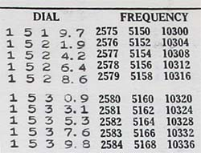
As you can see in the above example, any given dial position can be more than one frequency. Between three and four are what are normally documented in the calibration book, but there are actually even more.
To set the frequency 2.580, 5.160, or 10.320 MHz is simple, just adjust the dial to 1530.9, and you are there.
But how do you set a frequency not listed on the page, maybe something like 10.325 kHz? 10.324 and 10.328 MHz are both listed but not 10.325 MHz. Getting "between" the listed frequencies is pretty easy also.
1 - Pick the two closest frequencies on each side of the desired frequency, in our example 10.324 and 10.328 MHz. Their dial settings are 1533.1 for 10.324 MHz and 1535.3 for 10.328 MHz.
2 - Subtract the lower dial reading from the upper. In this case 1533.1 from 1535.3. This leaves 2.2 dial units between the two points.
3 - The subtract the lower frequency from the upper. 10.324 from 10.328 MHz leaves 4 kHz.
4 - Divide the number of dial units by the frequency span, in our example 2.2 units divided by 4 kHz. This leave .55 dial units per kHz. Naturally, we know that our dial is only good for tenths of a unit (x.1) and not hundredths (x.01), so we may have to round off a bit to make things work.
5 - Subtract the lower closest frequency form the frequency you want to be at, in our case the listed 10.324 from our desired 10.325. This leaves a difference of 1 kHz.
6 - Multiply the difference frequency times the dial units per kHz. In our example 1 kHz times .55 dial units, or a total of .55 dial units.
7 - Add the calculated number of dial units to the lowest documented dial units, in this case .55 added to 1533.1, for a new dial setting of 1533.65 being equal to 10.325 kHz. Our dial does not do hundredths, so we must round off to the closest tenth, or 1533.7 on the dial. This would actually leave us about 100 Hz high in frequency, but close enough.
It seems complicated, but again, just like reading the dial, after a few goes at it you can be very quick.

Presetting a CW, MCW, or AM receiver to a desired frequency.
To do anything with a receiver you must have the BC-221 and the receiver "loosely coupled". In general this means take a short piece of wire and attach it to the BC-221 antenna connection. Lay this piece of wire near the radio you will be using. It is now "loosely coupled". I just ran the wire along the back of my radio desk, then all of my radios were "loosely coupled".
1 - Turn on the BC-221 and allow it to warm up.
2 - Perform your CRYSTAL check closest to your desired frequency. After completion select OPERATE on the BC-221.
3 - From the calibration book determine and set the dial position needed for your frequency.
4 - Tune the radio receiver in the area of the desired frequency. You will pick up a strong signal that is the BC-221. You may want to disconnect and connect the BC-221 antenna so that you can tell you are on the right signal, here is were the LM series has a real advantage, you can turn the 500 Hz tone on and of to identify your signal. Peak the signal up on the receiver. You are now pre-tuned to a desired frequency, how closely you are pre-tuned depends on several factors, including how selective your receiver is. Spin the BC-221 dial so that it will not interfere with the signal you want to hear.

Determining the frequency of an unknown station your are monitoring.
Again, the BC-221 and the receiver must be "loosely coupled". We are assuming that you are listening to an unknown station at an unknown frequency, you can tell it is at "about" 10.3 MHz because that is what your BA dial is telling you.
1 - Turn on the BC-221 and allow it to warm up.
2 - Performed your CRYSTAL check based on the frequency displayed on the BA dial. After completion select OPERATE on the BC-221.
3 - Tune the BC-221 dial around the value indicated by the calibration book to be near the frequency of interest. I prefer to start low and work my way up in frequency.
4 - At some point you will hear the BC-221 signal sweep through the radio signal you are listening to. When you do, rock the dial of the BC-221 back and forth and "zero beat" the BC signal to the radio station.
5 - Read the dial of the BC-221 and find the frequency represented by this value in the calibration book. You may have to interpolate if the dial indications fall between documented points.
===================================================================================

Zenith BC-221 (T-version)
Frequency Meter
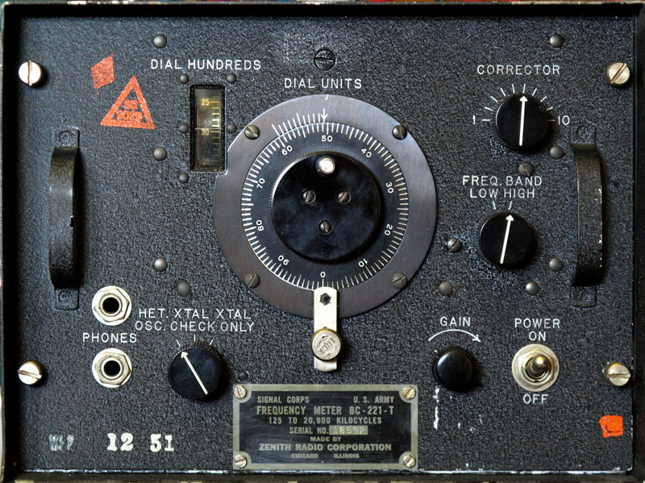
Zenith is my all-time favorite radio manufacturing company. During WW II they also made radios and test equipment for our troops; apparently some of their radar research is still classified according to "The Zenith Story". Reading this history was fascinating and it mentions a piece of test equipment called the Frequency Meter with "fantastic accuracy and sensitivity". There was another article that talks about the preparation of the frequency lists that's worth a read. Well that was it - I had to have one. A search on Ebay showed some for sale but with missing parts. I really wanted the manual with my unit so I started searching regularly on Ebay trying to find a complete one. I finally got one in July 2003 for $56. It also had a complete set of spare tubes not mentioned in the description. Initial tests showed it did not work so I set in the garage for later repair.
During fall 2011 I decided to get the Frequency Meter working. Checking the chassis there was no signal from the crystal oscillator. At first I couldn't even find the crystal. I finally noticed the big square looking thing with an octal tube socket and double checked the schematic. Wow, I think that's the biggest crystal I've ever seen. The manufacturing date on the crystal was May 1944 but some numbers on the front panel suggest the instrument was made in Dec 1951. Maybe it was used in Korea! Having nothing to lose I took the crystal case apart and was surprised what was inside. One side contained a temperature switch. I heated up the sensor and it still worked, popping loud as it opened the switch; I've seen this used on other equipment as a way to prevent overheating but it's strange that it would be used inside the crystal container. Anyway the other parts were even more unusual and amazing (see pics below). I soldered a more modern 1 MHz crystal in its place to the socket terminals and the circuit worked. Anyway, after this I decided to clean up the original crystal and put it back in the unit but it still didn't work. Tracing the wires inside the crystal case to the octal base showed why - the crystal wasn't even connected to the circuit. There were obvious signs of tampering on the socket; pieces of cut wire and solder on some terminals. The schematic did not show any thermal switch but it may have been hidden as part of the "crystal". It could be that the thermal switch had become intermittent and someone tried to bypass the wiring and failed. I corrected the wiring and the old crystal was now working!
I cleaned and lubricating all the controls, especially the trimmers (they were extremely hard to turn until lubricated); then I did a quick alignment and was amazed how accurate this unit was; "good enough for government work" as they say. Looking at the frequency chart the precision is as follows:
Freq Range Accuracy Band
125 - 250 KHz 100 Hz Low
250 - 500 KHz 200 Hz Low
500 - 1000 KHz 400 Hz Low
1000 - 2000 KHz 800 Hz Low
2000 - 4000 KHz 1000 Hz High
4000 - 8000 KHz 2000 Hz High
8000 - 16000 KHz 4000 Hz High
16000 - 20000 KHz 5000 Hz High
Any frequency between 125 Khz and 20 MHz can be obtained with this unit.
The quick calibration works by tuning the "Crystal Check Points". There is a Xtal check point on each page allowing for much improved accuracy even for a unit this old. Turn the switch to Xtal Check, dial in the numbers for the Crystal Check Frequency on the page needed for your frequency; then zero-beat the tone for lowest tone using the "Corrector" dial (you should be able to make the tone almost disappear for the best reading).
Now you’re ready to align your equipment. It's very time consuming but it works and it works very well. The only caveat is to know which harmonic you're on and double check it. The "HET OSC." mode is used to check transmitters allowing the unit to become an accurate receiver using heterodyne to tune the transmitter oscillators. With a long wire connected to the terminal you can receive some shortwave stations but only the strongest harmonic will come through. WWV for instance is on every harmonic when tuned to 5000 KHz so you might here 3 different stations at once!! You will also still hear the het oscillator but it can be nulled to be able to hear voice.
The "XTAL ONLY" is used to calibrate receivers providing an accurate transmitted CW signal which can be used to tune the oscillators of the receiver.
You can use 2 sets of headphones. A plug must be inserted (in either jack) to apply power even if the power switch is on. A contact switch is built into the phono plug. This was to conserve battery life for the 6 V battery; the high voltage stays hot with the power on and phono plug disconnected. I used alligator clip test leads to connect the three power connectors when out of the chassis and an empty 1/4" phono connector to keep the power on. The newer headphone (8 ohm type) will work but the volume will be very low. The high impedance type (~1000 ohm) will provide maximum volume. If you have good hearing then the 8 ohm type might be better since the clicks and beat-frequencies will not hurt your ears. Most of the 1st harmonic crystal check frequencies are very loud!
(The Russians apparently had a knock-off of the BC-221 called the CH4-1, AKA 526u; they looked very similar and was most likely copied from the BC-211).

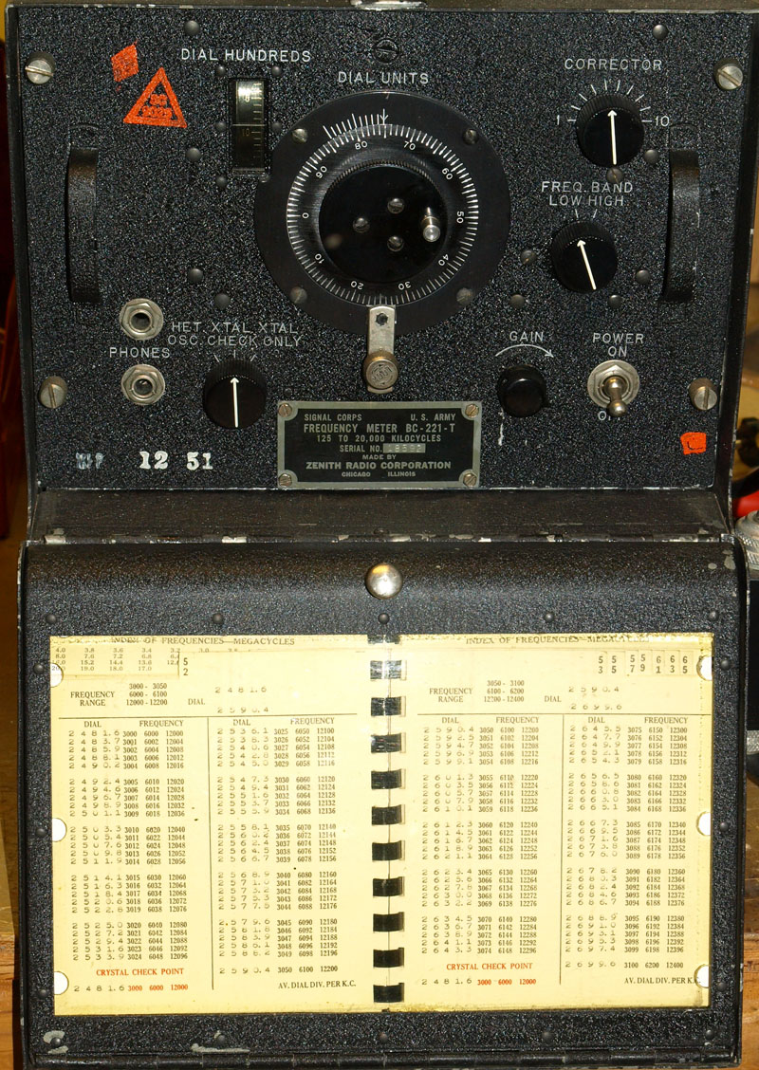
The front cover flips open to reveal the frequency dial settings.

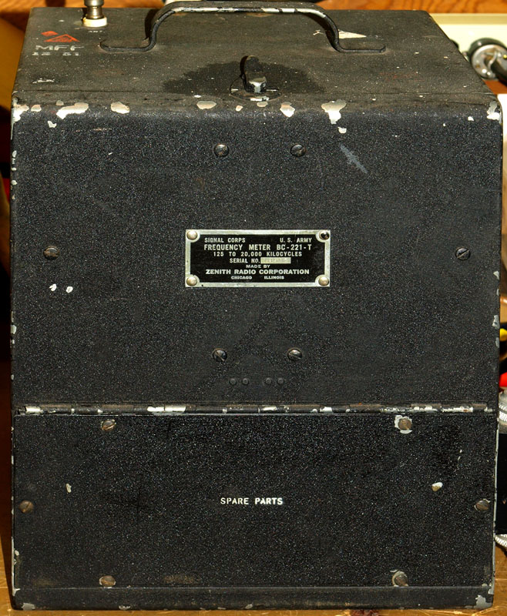
The cabinet has seen better days but it's staying this way.

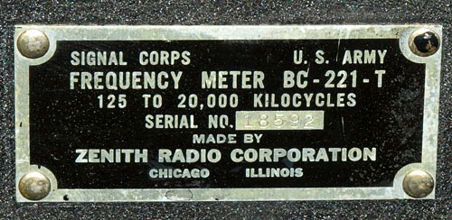
Serial Plate on the outside of the cabinet.

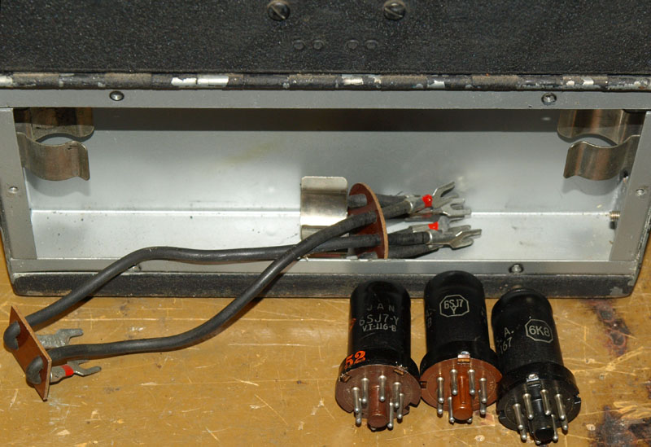
Complete set of spare tubes in the Spare Parts compartment. I believe the wire harness is for the old type dry cell batteries and looks unused. This unit was retrofitted with an AC power supply which looks factory furnished.

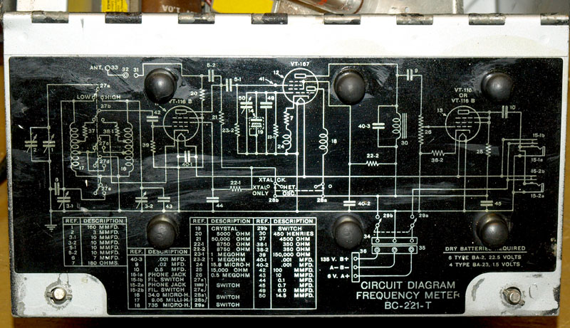
The battery compartment opens up with the schematics on the other side of the cover.

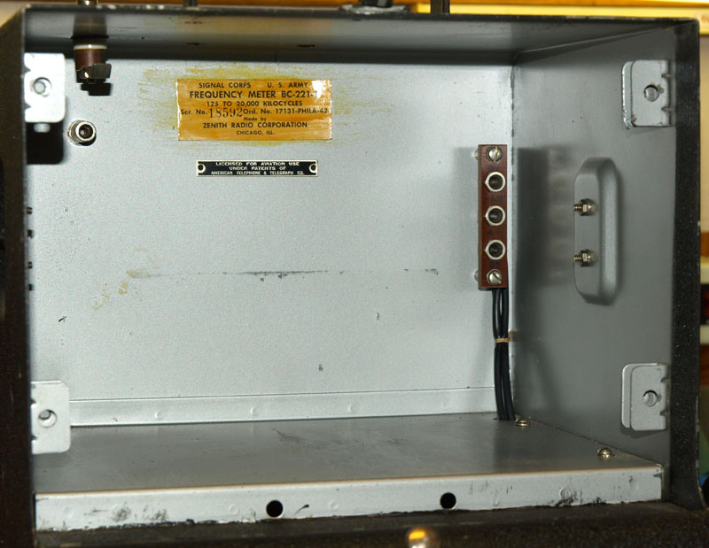
The electronics can be pulled out of the cabinet. Note the docking adapters in the back.

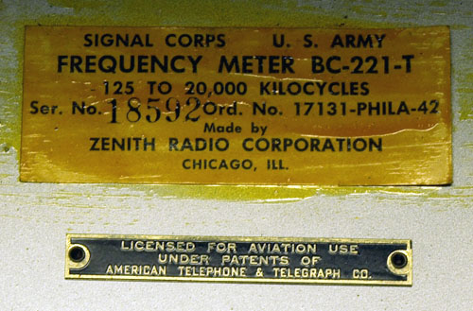
Label in the back of the cabinet.

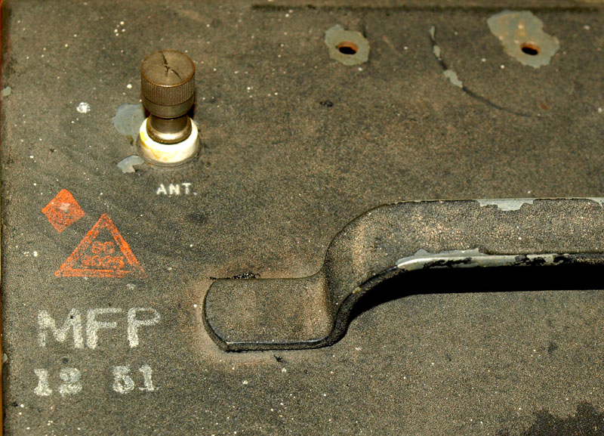
The antenna connector is also connected with a docking adapter.

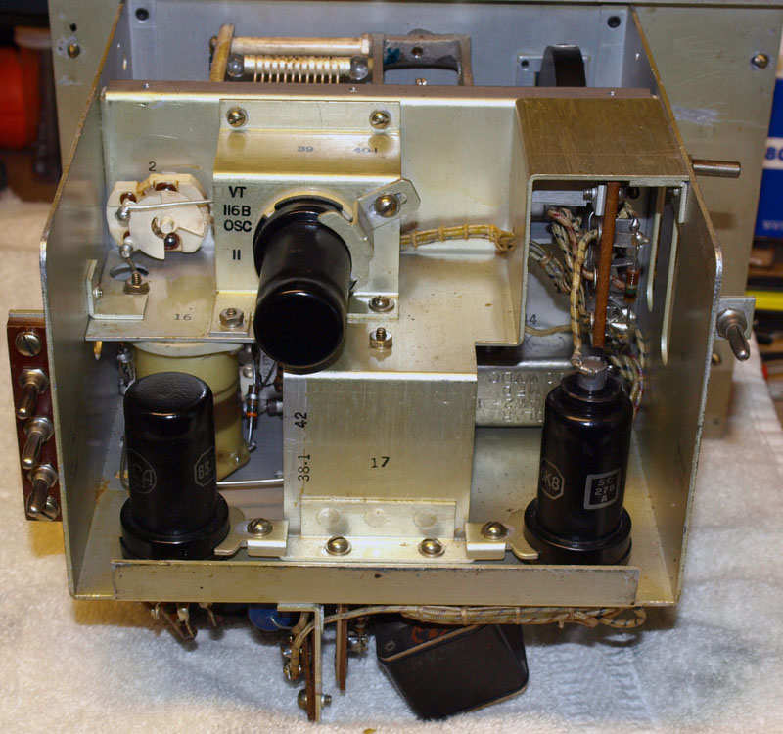
Chassis looking from the rear.

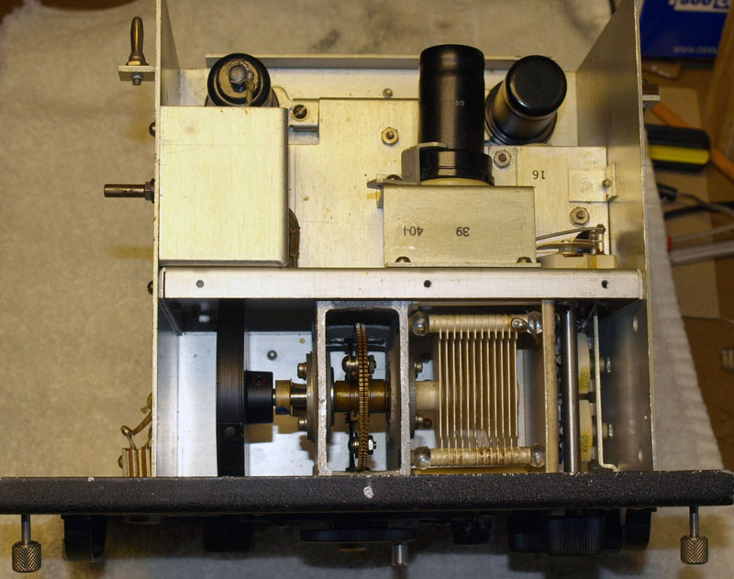
Chassis looking from the top. Cover shield has been removed for this picture.

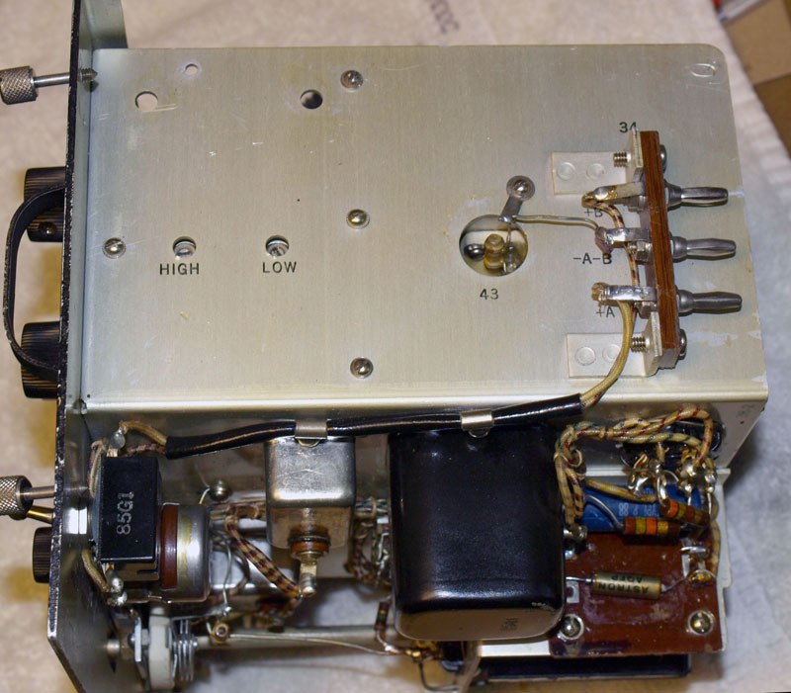
Chassis looking from the power docking adapters. The two trimmers for high and low oscillator adjustment can been seen.

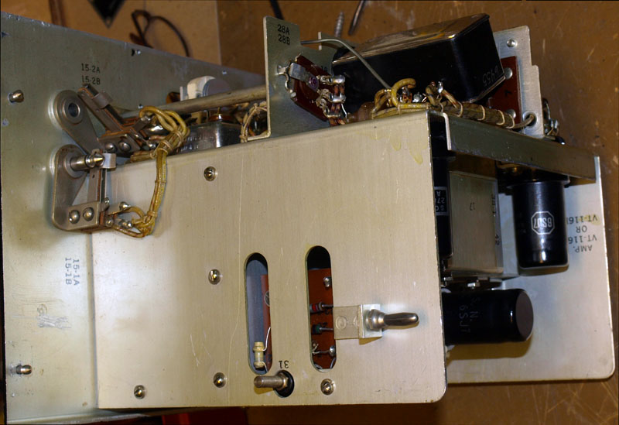
Docking adapters on the other side (ground on the right, antenna on the left).

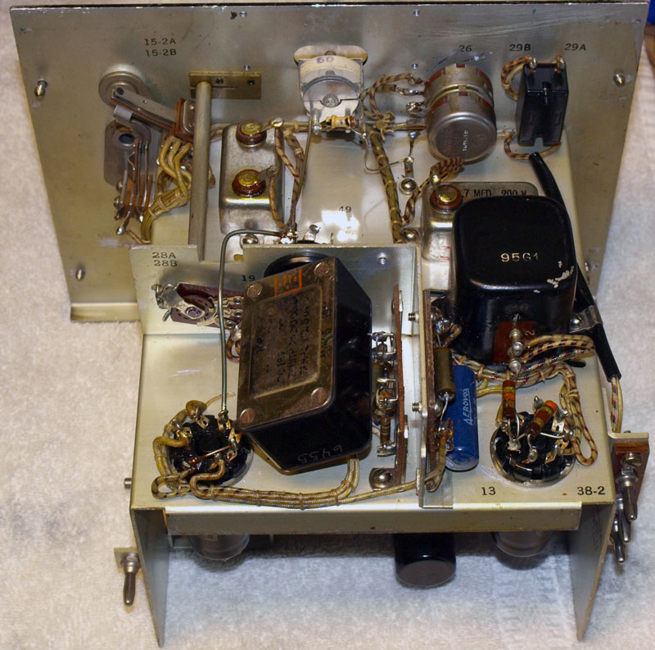
Chassis looking from the bottom. The large rectangular box with metal covers is the crystal. The master trimmer (top, center) can be access behind the front serial plate. Placing the scope probe near the crystal will provide a nice signal on the scope with no effect on the circuit. Tune the master trimer for maximum signal.

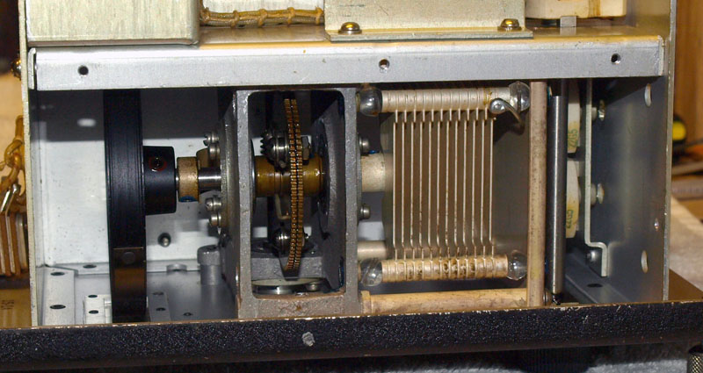
This is the main tuning capacitor. Note the glass beads holding the plates in place for maximum isolation (cover shield removed). Dual spring-loaded drive gears prevent any backlash in the drum dial.

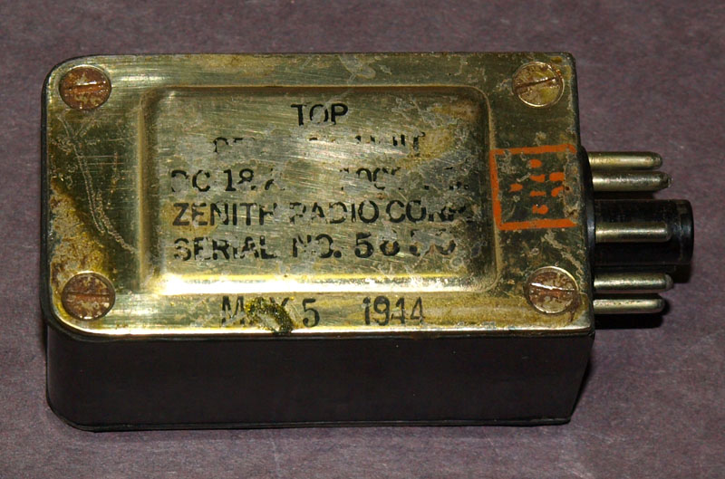
Crystal top; manufacturing date "May 5, 1944"

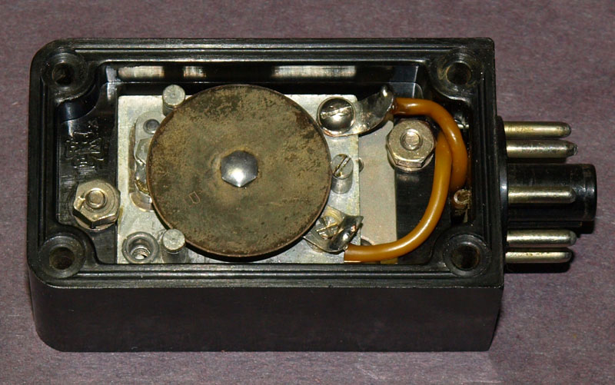
Cover open to show the temperature sensor. The round disk is temperature sensitive pushing on a contact switch below it. This contact is no longer part of the circuit. One screw is shown removed (bottom left) which contained a grounding clip for the metal case

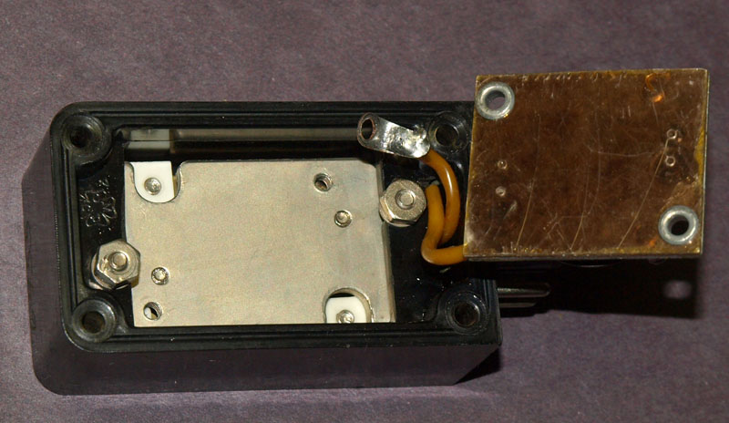
Temperature sensor flipped over. The upper plate contains about 1/16" layer of mica as an internal capacitor between the crystal contact plate and the upper contact to the tube socket.

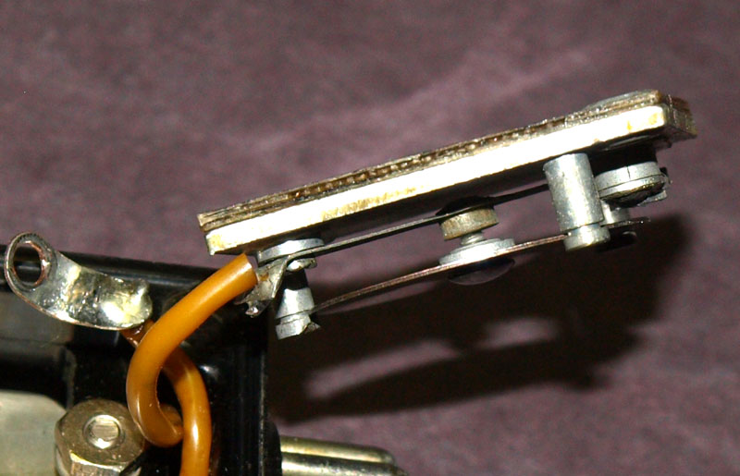
Relay in the closed position (this is the normal position). Mica insulator can be seen facing up.

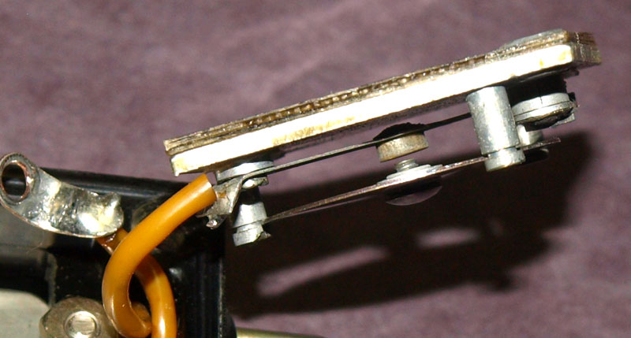
I applied heat to the sensor and it pops - opening the contact.

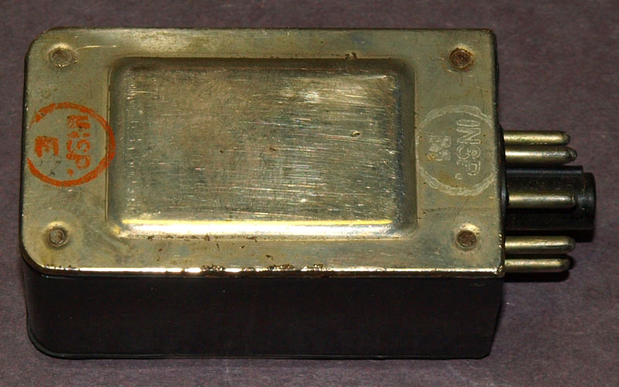
Crystal bottom

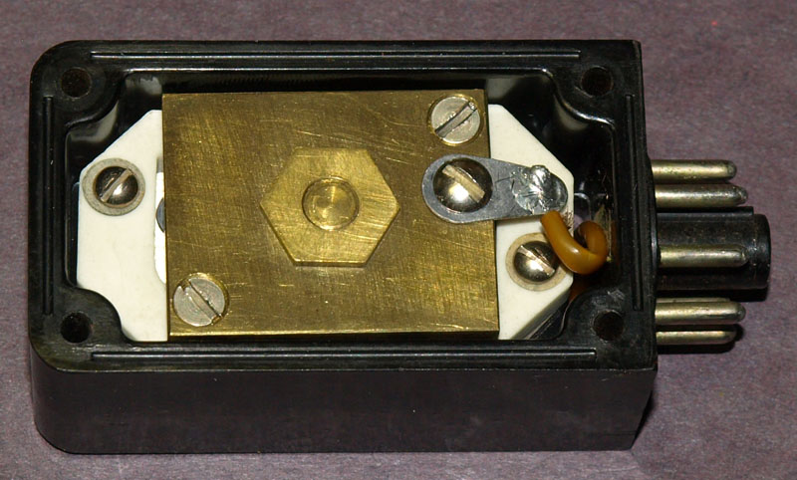
Cover open to show the contact plate for the crystal.

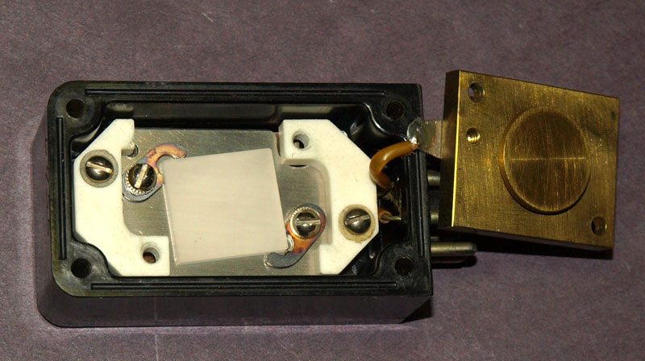
Crystal plate flipped over to reveal the large square crystal underneath. The clips on opposite corners are just touching and do not distort the crystal. The white spaces are insulators.

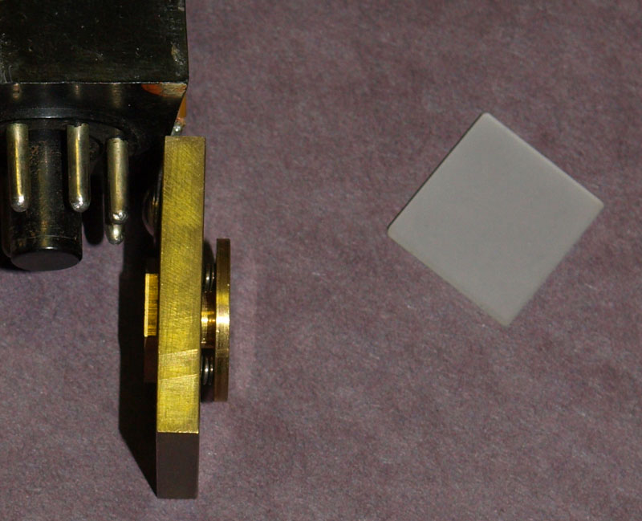
There are three springs under the pressure plate for perfect planar contact with the crystal.

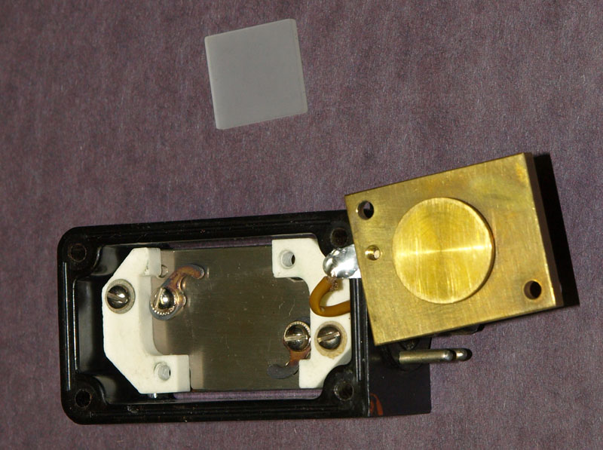
Crystal just falls out so be careful!

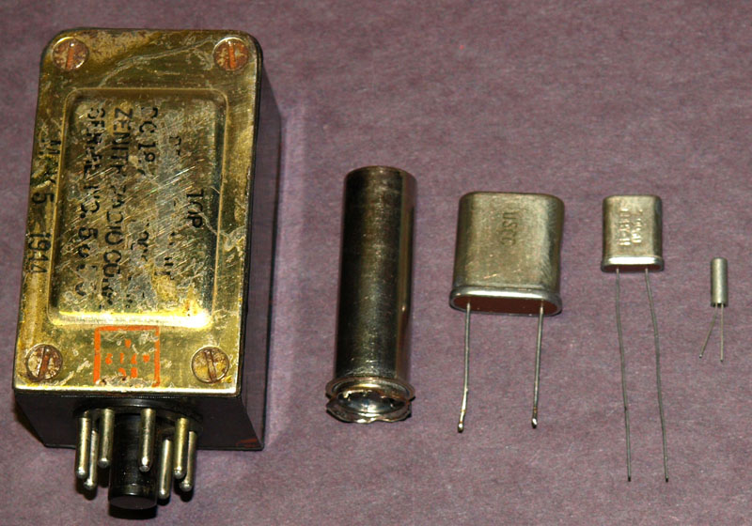
Comparison of several crystal packages (the smaller, the more modern)!

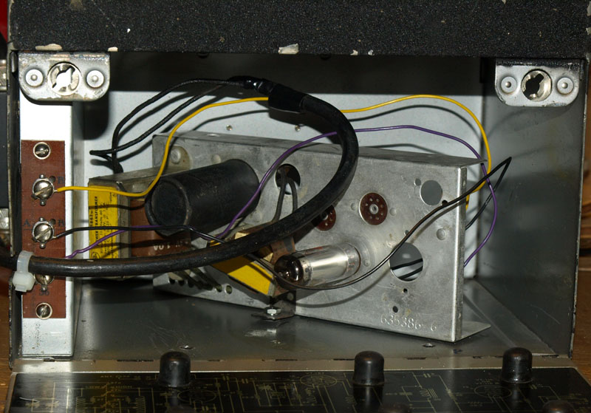
Power supply located in the cabinet so batteries are no longer needed.

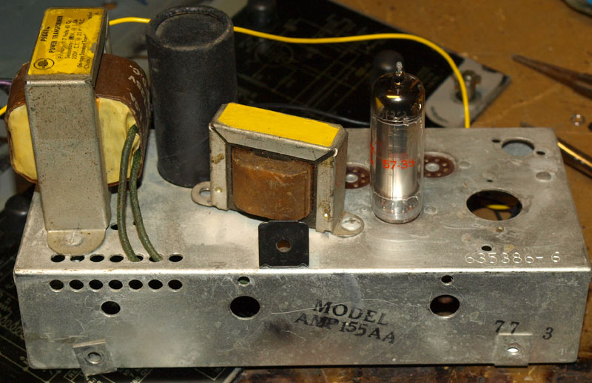
This appears to be a factory retrofit and has been further modified.

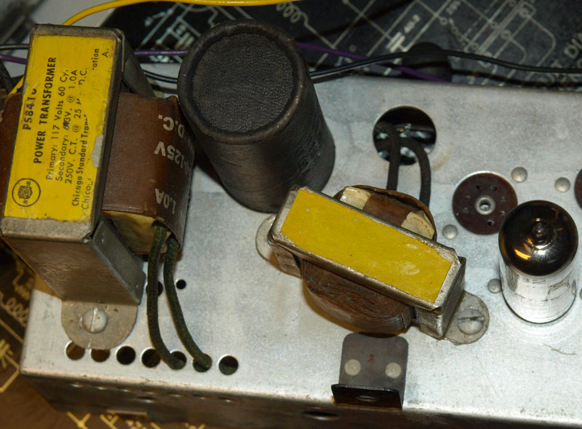
Close-up of the power transformer and filter choke. The capacitor is a dual 40 uF. The filament winding is fed directly to the A+ terminal for all the tubes.

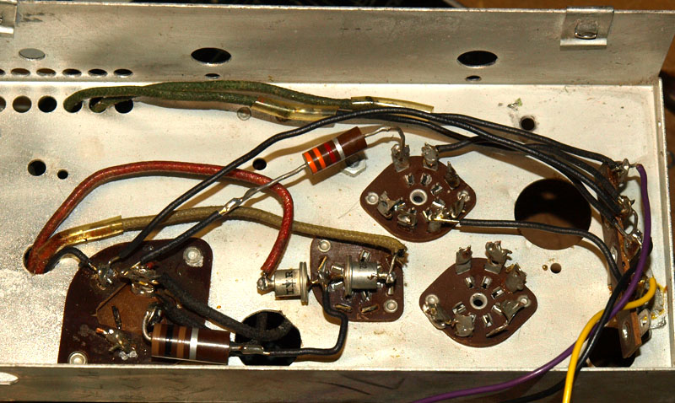
The 2 rectifier tubes have been replaced with two 3-amp silicon diodes. The remaining tube is a cold-cathode voltage regulator. One hole had no socket; possibly for a diode tube providing a DC voltage for another piece of equipment.

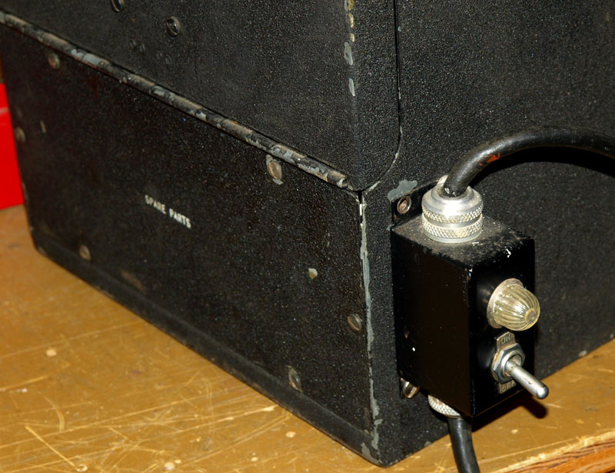
Power switch mounted on the side of the cabinet.

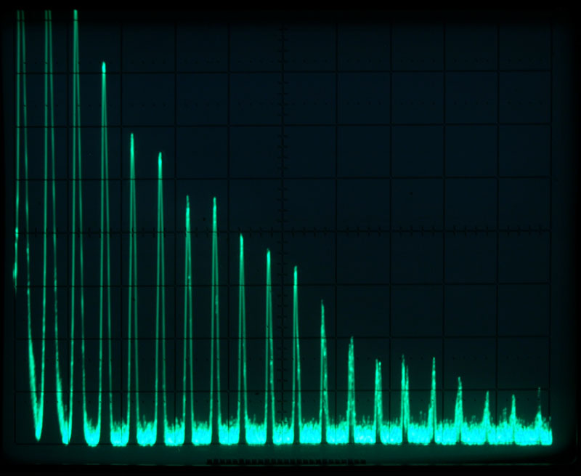
This is the crystal-only spectrum starting at 1 MHz with tapering harmonics (0 - 20 MHz span)

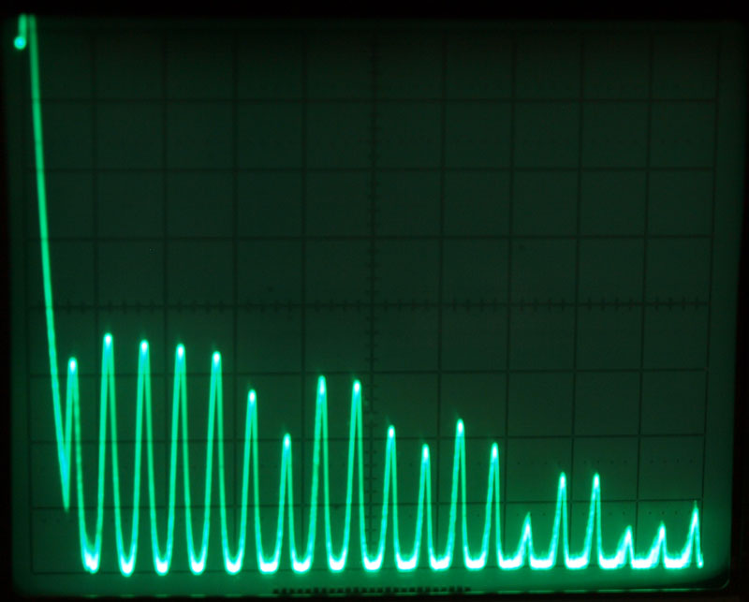
Tuning capacitor spectrum; switch set to Low-band at minimum setting (0 - 5 MHz span)

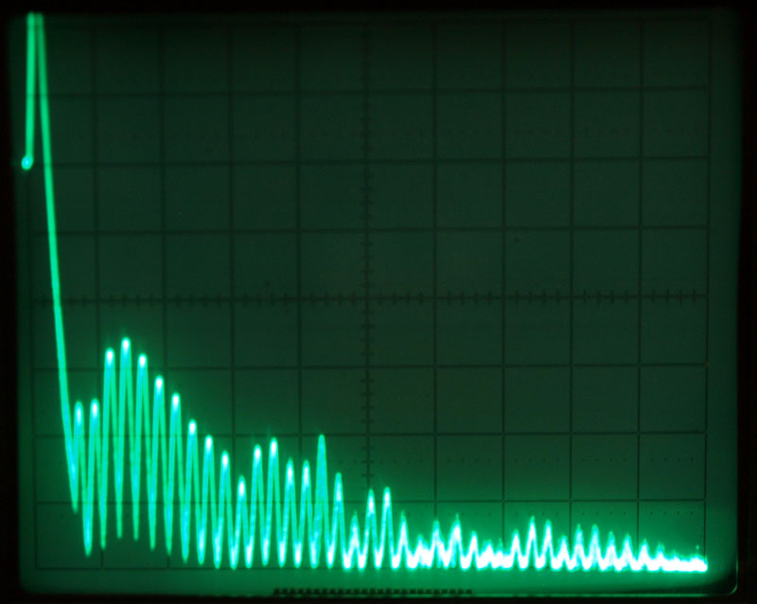
Tuning capacitor spectrum; switch set to Low-band at maximum setting (0 - 5 MHz span)

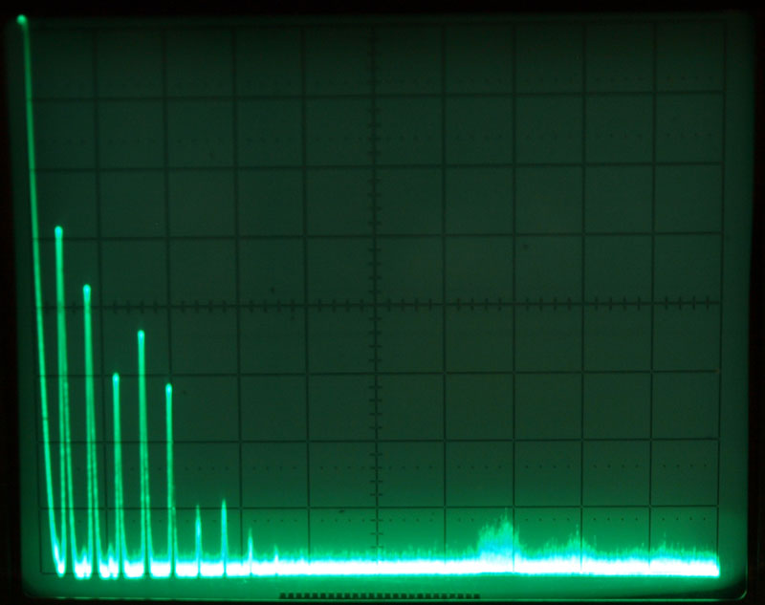
Tuning capacitor spectrum; switch set to High-band at minimum setting (0 - 50 MHz span;
the noise to the right was an outside noise source)

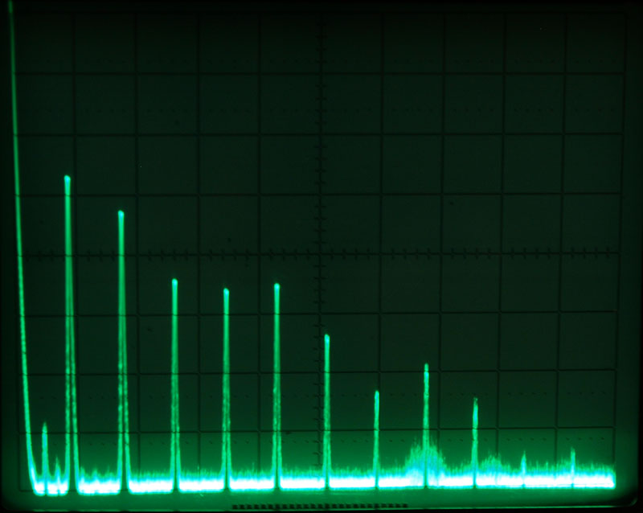
Tuning capacitor spectrum; switch set to High-band at maximum setting (0 - 50 MHz span)

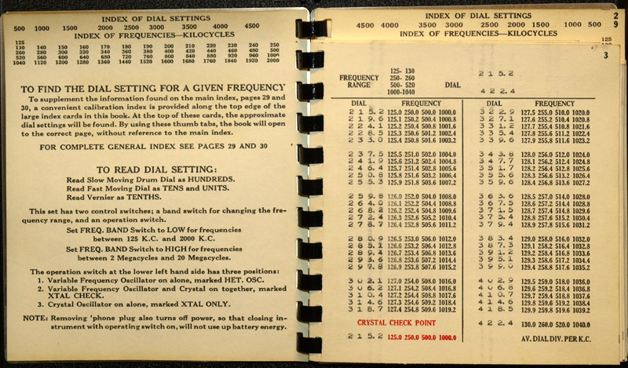
First page gives some quick instructions.

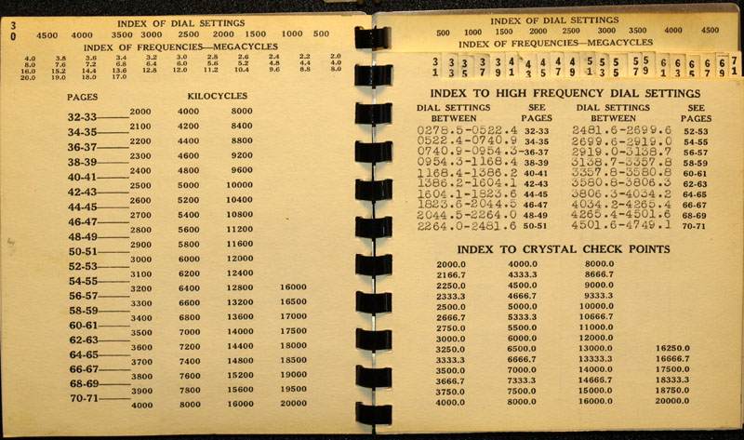
This divides the low and high band frequency lists.

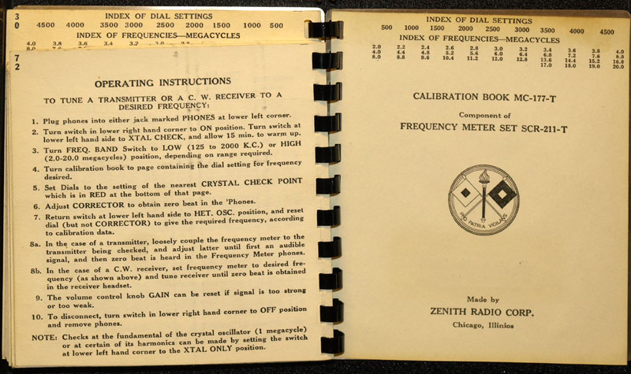
A brief set of operating instructions.

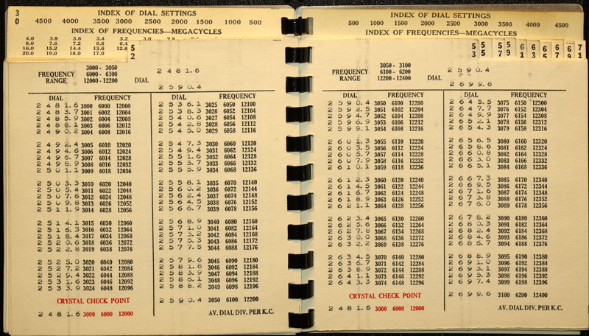
An example page of frequencies. Note the crystal check points at the bottom of the page.

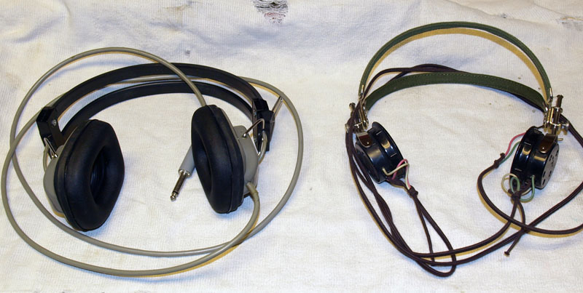
The headphones on the left are typical 8 ohm modern type. They will work with reduced volume. The high impedance type on the right work very well. These are from the Vietnam era that I got on Ebay.

All web content is copyright - John G. McClung

FREQ MTR | MFR | TUBES USED | CRYSTAL DC-9-? | CASE MAT'L | WT LBS | AUDIO OUTPUT IMPEDANCE
BC-221-A | CRR | 6A7, 76, 77 | A | ALUM | 38.5 | High or Low
BC-221-B | CBK | 6K8, 6SJ7(2) | B | ALUM | 38.0 | High or Low
BC-221-C | CRR | 6A7, 76, 77 | C | ALUM | 38.5 | High or Low
BC-221-D | CRR | 6A7, 76, 77 | D | ALUM | 38.5 | High or Low
BC-221-E | CPR | 7A4, 7B8LM, 7G7 | E | ALUM | 38.0 | High or Low
BC-221-F | CZR | 6A7, 6SJ7Y, 76 | F | ALUM | 38.0 | High or Low
BC-221-J | CZR | 6A7, 6SJ7Y, 76 | J | ALUM | 38.0 | High or Low
BC-221-K | CZR | 6A7, 6SJ7Y, 76 | K | ALUM | 38.0 | High or Low
BC-221-L | CZR | 6A7, 6SJ7Y, 76 | L | ALUM | 38.0 | High or Low
BC-221-M | CRR | 6K8, 6SJ7, 6SJ7Y | M | ALUM | 38.0 | High or Low
BC-221-N | CPR | 6K8, 6SJ7(2) | P OR AD | ALUM | 36.0 | High or Low
BC-221-O | CIY | 6K8, 6SJ7, 6SJ7Y | P OR AD | ALUM | 39.0 | High or Low
BC-221-P | CZR | 6K8, 6SJ7, 6SJ7Y | P | ALUM | 38.8 | High or Low
BC-221-Q | CBK | 6K8, 6SJ7(2) | Q | EITHER | 38.0 | High or Low
BC-221-R | CIY | 6K8, 6SJ7, 6SJ7Y | P or AD | ALUM | 38.0 | High or Low
BC-221-T | CZR | 6K8, 6SJ7, 6SJ7Y | T | ALUM | 42.3 | High or Low
BC-221-AA | CPR | 6K8, 6SJ7(2) | P or AD | EITHER | 35.5 | High or Low
BC-221-AC | CIY | 6K8, 6SJ7, 6SJ7Y | P or AD | WOOD | 43.0 | High or Low
BC-221-AE | CPR | 6K8, 6SJ7(2) | P or AD | WOOD | 36.2 | Low
BC-221-AF | CZR | 6K8, 6SJ7, 6SJ7Y | T | WOOD | 39.5 | Low
BC-221-AG | CPR | 6K8, 6SJ7(2) | P or AD | WOOD | 36.2 | Low
BC-221-AH | CZR | 6K8, 6SJ7, 6SJ7Y | T | WOOD | 39.5 | Low
BC-221-AJ | CIY | 6K8, 6SJ7, 6SJ7Y | P or AD | WOOD | 40.0 | Low
BC-221-AK | CPR | 6K8, 6SJ7(2) | P or AD | WOOD | 36.0 | Low
BC-221-AL | CZR | 6K8, 6SJ7, 6SJ7Y | P or AD | WOOD | 40.0 | Low

